**Project Description:**

Trisakay is a tricycle riding app that allows both drivers and passengers to have a more convenient experience when it comes to commuting. For drivers, the app should allow them to more easily locate potential passengers along their chosen route. For passengers, the app should allow them to quickly identify drivers in their area that are along their chosen route so that they can more easily catch a ride. Overall, it should improve local commuting experiences for both drivers and passengers in subdivisions that have available tricycle riders in them.

**Requirements Summary:**

|  |  |  |
| --- | --- | --- |
| **MINIMUM REQUIREMENTS** | Processor Cores | Single Core |
| OS | Android 4.4 (KitKat) |
| RAM | 2 GB |
| **RECOMMENDED REQUIREMENTS** | Processor Cores | Quad Core |
| OS | Android 8.0(Oreo) |
| RAM | 4 GB |
| **OTHER REQUIREMENTS** | Permissions | Notifications and Storage |

Table 1. System Requirements

To cater to low-end android models, the application will have at most a minimum of 1 Core, 2 GB worth or RAM, and Android version 4.4 or KitKat as its OS. The app itself is not at all demanding, hence our team has settled on lower requirement specs.

# Overview

Due to the ongoing quarantine and online classes, the team is unable to conduct this evaluation through normal means. Instead, alternatives were used such as the use of online social media platforms such as Microsoft Teams and Discord. This is to ensure that the pair will still be able to see a live feed of what is currently happening in the prototype.

With that said, the Evaluation plan is split into three separate parts: Usability Specifications, Heuristics Evaluation, and Participant Survey and Feedback. Below is a table describing each technique.

|  |  |
| --- | --- |
| **Technique** | **Description** |
| Usability Specifications | Usability Specifications is the technique used to evaluate the level of usability that the Prototype has. It consists of tasks that will be done by Participants. Furthermore, the Technique will contain timing the speed of the participants at a given task. The tasks will be split into 3 Sections: Main Menu Task, Folder Tasks, and Quiz Tasks. This task is chosen to properly identify what flaws are seen when the user interacts with the prototype and how easy it is to use said prototype. |
| Heuristics Evaluation | Heuristics Evaluation will evaluate the UX design of the Prototype in an industrial-standard usability principle. This technique is chosen to provide a quick and approachable way to assess the validity of the Prototype’s Design when time or resources are less. |
| Participant Survey and Feedback | A survey will be provided to participants after conducting the prototype. The survey will contain quantitative questions that are interpreted into a 5-point Likert Scale as well as Qualitative questions in the form of Feedbacks. This will ensure that no designer bias will be done to the result of this evaluation. |

The tasks for this Prototype are split into three (3) different Sections: Main Menu Tasks, Folder Tasks, and Quiz Tasks. Below are some of the tasks that the selected participants will be asked to perform for each Section to showcase the Prototype’s functionality:

* Enter and Exit the Prototype (**Main Menu Task**)
* How easy will the user be able to navigate while using the Prototype.
* Participants will be tasked in creating files and folders (**Folder and Quiz Tasks**)
* Participants will be tasked in deleting files/folders (**Folder Task**)
* Participants will be tasked to edit files (**Folder and Quiz Tasks**)

Reasons that these tasks were selected for the participants since the Prototype was designed with these measures in mind:

* Easy Navigation
* Allow users to do CRUD (Create Read Update Delete)

Method of conducting Online Tests:

Social media platforms were used in conducting the online tests for this evaluation. Below are screenshots showing how the evaluation underwent.

# Data Presentation

**Data Analysis**

## Usability Specifications

During the online testing with the Participants, Team TAAL has noticed that the participants during this test have been interacting rather well with the prototype. Almost all the Participants were able to finish each task handed to them by the Members of the Team and were accomplished with little to no issues. Upon further observation, the participants were able to learn and memorize the steps and navigation of the Prototype. They were able to easily navigate their way through the prototype. However, some buttons on the Prototype were inattentive when the participants attempt to click. This is presumed to be constraint issues that were missed by the pair during the designing of the prototype.

|  |  |  |  |
| --- | --- | --- | --- |
| Task | Mean | Interpretation | Classification |
| Main Menu Task |  |  |  |
| Folder Task |  |  |  |
| Quiz Task |  | Highly Acceptable | Successful |

Table 3. Task Time

Table 3 shows the results of the timed tasks during the Online Testing. The data shows that the Participants were overall able to accomplish each task sections with amazing times. With this result, the prototype is interpreted as successful in all three (3) task sections.

## Heuristic Evaluation

The SASHA prototype will be evaluated within each type of Heuristic Evaluation.

### Visibility of System Status

The prototype was able to inform the participants what was going on within the Prototype.

### Match Between System and Real World

The prototype uses basic English which can easily be understood by all ages within our participants. Words and Phrases easily understood by the Participants.

### User control and Freedom

The prototype possesses fail-safes such as “Cancel” and “X” whenever participants were mis-clicking or did not understand the instructions clearly. Back Buttons were also implemented as another form of Fail-safe.

### Consistency and Standards

Consistency was followed with a bit of issues here and there. Issues such as inconsistency with the position of the Back buttons and location of where to tap.

### Error Prevention

Error prevention was followed to some degree with a few mishaps in the prototype. Such errors were minor but still affected the participant’s experience to some degree.

### Recognition rather than recall

Options, objects, and actions were visible for the user to use during the Prototype.

### Flexibility and Efficiency of Use

The prototype was easily understood and used proficiently by both the experienced and inexperienced of the FIGMA style prototype.

### Aesthetic and Minimalist Design

The Prototype has a slick and simple that connects to the previous plan of ModernMinimalistic feel. Furthermore, information that are of no necessities were not shown within the prototype.

### Help Users Recognize, Diagnose, and Recover from Errors

Unfortunately, the prototype suffers from this Evaluation type. While the Prototype does indicate the user when they have clicked a part that has no interaction, the prototype was still unable to Help users with Plain Language, only indicators.

### Help and Documentation

Users were able to access Help or Assistance through the form of the present team members.

### Heuristics Conclusion

Overall, the Prototype was able to follow most of the Evaluations with some issues that still need to be properly addressed or fixed.

## Participant Survey and Feedback

**Results**

|  |  |  |  |
| --- | --- | --- | --- |
|  | **SECTION 1** | |  |
| Question | Mean | Interpretation | Remarks |
|  |  |  |  |
|  |  |  |  |
|  |  |  |  |
|  |  |  |  |
|  |  |  |  |
|  |  |  |  |
|  |  |  |  |
|  |  |  |  |
|  |  |  |  |
| J. |  |  |  |
|  | **SECTION 2** | |  |
|  |  |  | Unsuccessful |
|  |  |  | Successful |
|  |  |  |  |
| **Average** |  |  |  |

Table 3. Survey Data Interpretation

The table represents that data for the survey conducted after the online testing. It shows that the prototype is at an Acceptable stage of quality and is deemed Successful. The pair would still however, like to focus on the Renaming of Files and Folders which seems to have a Neutral consensus. Using the 10 Usability Heuristics Criteria, this data shows that the prototype was able to please the participants and follow the criteria with key points such as its Minimalistic Approach and Visibility.

Feedback

While most of the feedback were overwhelmingly positive. Some feedbacks are focused on a few issues. Such common issues revolve around the renaming feature of the Prototype. These issues tend to raise concern that the Renaming was somewhat difficult to follow.

**Design Implications:**

● Does your prototype need to be altered in order to address the results of the analysis, or was it completely successful?

○ The results of the Prototype show it was very successful and is at an acceptable stage. However, the team still decided to improve upon the Renaming of File/Folders since many Participants state their dismay when doing this task.

Below are some of the feedbacks that state their concerns about this feature:

### ■ The renaming for editing part should be fixed

■ *Application Navigation are inconsistent as well as renaming files/folders.*

● What improvements could be made to the design to address any shortcomings? ○ To fix this issue, the pair has decided to add “Pencil” icons in each file and folders. Not only will this retain the original “Hold to rename” aspect of the prototype which borrows from the Android GUI, the Prototype now provides a way for users to rename a file or folder through this new Icon.

**Before Alterations** **After Alterations**

Changes were also made for the Task Icons which also had Pencil Icons. With the original being Rounded Squares, which are now change to Full Circles to signal where they can tap to edit the name.

**Before Alterations** **After Alterations**

Did you discover any major flaws that would suggest a completely different type of design? ○ No major flaws but there were flaws from the original idea from part 2 where the design would potentially not be well received. The following flaws are as seen below:

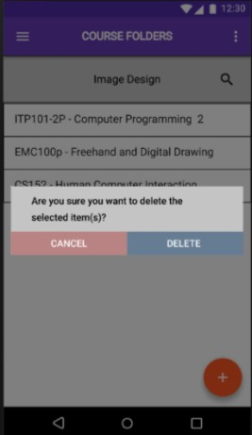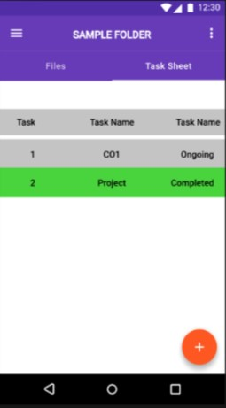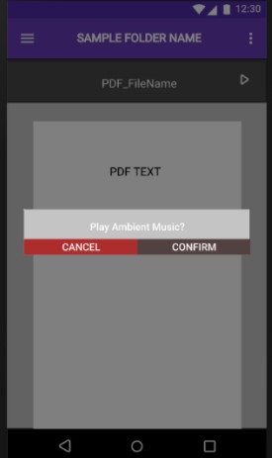

|  |  |  |
| --- | --- | --- |
| **Does not indicate**  **number of deleted**  **files/folders.** | **Requires more inputs such as Task number and Initial Progress.** | **Could potentially annoy users if it pops up when entering in a file.** |

○ There were a few issues with the recent Design that the team would also like to address. The issue being that the constraints of some button seemed out of place and needed to be adjusted.

**Critique and Summary:**

What were the advantages and disadvantages of your evaluation?

* The advantages of doing this evaluation were that the team was able to gather much needed information and data that are essential to the prototype. It was also easier to contact participants for the online test evaluation to which was successful and provide them with the necessary links using social media. However, the downside of all this is that there was not enough physically contact, or laboratory works that could potentially collect more data for the prototype. Moreover, with the constant issues with the internet here in the Philippines, the team has often found themselves waiting before a participant can fully be contactable since internet speed factored in how well the team can observe the interactions. Essentially slower net meant that it would be more difficult to assess the prototype on screen.

What would you have done differently knowing what you know now (both designwise and evaluation-wise)? Given more resources, what could you have done that would have produced significantly more insightful evaluation results (again, whether this is an improved prototype or a different evaluation path).

* Given more time, the team would have thought of two separate evaluations, one for the proposal prototype and another for the revised prototype. This would potentially provide the prototype with much needed evaluation to be fully completed. Furthermore, with much more resources, the team thought that it would be possible to implement back-end coding to further solidify the prototype solution into a functioning application that can be submitted to the app stores worldwide. Furthermore, the team would have improved the prototype by adding more features such as the Notifications and the online features.

Summary of the Project

that were vital to the Prototype itself. The selected benchmark tasks were necessary to see how well a user can interact with the Prototype. It would benefit the team greatly knowing which areas could be further improved. The aspects that worked in this Prototype were the CRUD system and its easy navigation, although there were some drawbacks such as the Rename Issue and the Inconsistent Navigations. The team also failed to implement online features which would have provided Participants more to do within the prototype but was cut short due to lack of time. If the team would have more time, the implantations of online features, music features, and many more would be added to give the prototype a more unique and fresher feel to it.

The conclusions that the pair can draw from this study is that designing a prototype is difficult, it requires sufficient knowledge and background with designing interfaces as well as a clear understanding of the problem and the users that they are trying to cater to. It is with this study that the team was able to fully realize how well-versed the participants were in android UI, even though it was their first time interacting with the Prototype. Overall, the team concludes that the overall design of the Prototype was acceptable and effective enough to be considered a success.